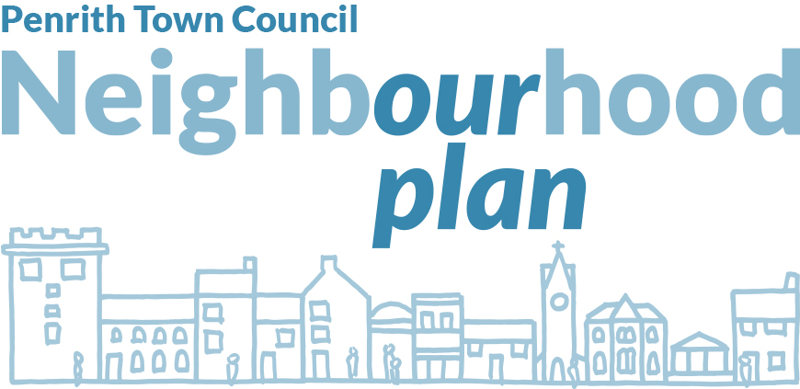

PLEASE COMPLETE AND RETURN THE QUESTIONNAIRE TO US BY 1st May 2017

This questionnaire will give us important information about what you think of Penrith. We particularly want to hear from younger people as your views are not heard as loudly perhaps as they should be and this is also your town. You do not have to complete all the questions.
You can complete and return this copy to us at Town Council Offices, 1st Floor, St Andrew’s Churchyard, Penrith CA11 7XX

Cllr David Whipp Cllr Fiona Johnson
Mayor Chairman
Penrith Town Council Neighbourhood Plan Group

QUESTIONS

Transport
1. Do you think there a parking problem in Penrith? Yes No
If yes think there is a problem (and this includes residential areas) where is it and what are the possible solutions

2. Is signage adequate for those in a vehicle or on foot / bike?
Yes No Not Sure
If you answered no, what would improve it?

3. It has been suggested that some of Penrith should be pedestrianised, do you agree? Yes No
Where could be pedestrianised or give your reasons if you said no

4. Do we need to look at a one way system or ring road for Penrith?
Yes No Not Sure
Any comments

5. Do we need improved cycle and walking routes round the town?
Yes No Not Sure
Please give more details

Leisure, Wellbeing and Green Spaces
6. Are green spaces important in the town? Yes No
Which ones are important to you, please tick all that apply
Fairhill Playing Field |  | Coronation Gardens
Castle Park |  | Wetheriggs Country Park
Childrens Play Areas |  | Thaka
Musgrave Street, Folly Lane, Salkeld Road and James Street Allotments

If there are other green spaces please specify

7. How could we improve communal green spaces? Please tick all that apply
Improved planting
Play areas for younger children
Outdoor gym equipment
Community orchards

Any other ideas – please specify

8. What are your views on leisure or recreational facilities both indorr and outdoor, do we need anything else?

9. What would you like to see as an arts / cultural offer in Penrith?

10. Are educational facilities and health facilities (Doctors, Dentists etc) sufficient – particularly when Penrith grows?

Housing / Development
11. Between now and 2032, how many NEW houses do you think should be built in Penrith?
 | Up to 500 |  | 2000-4000
 | 500-1000 |  | 4000 +
 | 1000-2000

10. Where could new houses be built in and around Penrith, this could include sites currently occupied other than by housing?
Carleton
White Ox
Raiselands
Fairhill (NOT the playing field) towards Stoneybeck)
Please specify any other locations

11. Where should not be developed?

12. What sizes of house are required Please tick all that apply
1 Bedroom
2 Bedroom
3 Bedroom
4+ Bedrooms
Please let us know if you have any specific comments

13. What styles of houses are needed? Please tick all that apply
Detached |  | Smaller Bungalows
Semi Detached |  | Larger Bungalows
Terrace |  | Retirement properties
3 Storey Town House |  | Flats
Other – please specify

14. Should new properties be available as:
Open Market |  | Affordable
Social Rented |  | Part Rent / Part Buy
Private Rented |  | Starter Homes
Self Build
Other (please specify)

15 Should new build include green / environmental features such as
PV / solar panels
Rainwater harvesting
Bird / Bat boxes
Other – please specify

Town Centre, Heritage and Assets
16. Is the appearance of the town centre?
Good
Neither good nor poor
Poor
Give reasons for your answers and tell us what would improve it

17. Is the retail mix in Penrith?
Good
Neither good nor poor
About Right
Poor
Please comment

18. How can we help shop fronts make the town attractive?

19. Are street furniture (benches, litter bins, bus shelters, planter boxes) and public toilets
Good
Neither good nor poor
Poor
No opinion
Any comments

20. Should we protect the character of the conservation areas and listed buildings?

Yes
No
Don’t know
How could we protect them?

21. If new buildings and extensions are built in conservation areas or on listed buildings should they look the same or be a contrast

22. We can ask for the registration of local heritage assets which can include parks, green spaces, specific pieces of land with historical significance. Do you think we have any such assets in and around Penrith and why do you think they are significant?

Business and Tourism
23 Where should businesses be located?
Gilwilly |  | Other sites within Penrith
Penrith Business Park |  | Other out of town sites
If you’ve specified other sites please detail where

24. What sort of business do we want to attract to Penrith and what could we do to attract them?

25. What premises and facilities do businesses want?
Large buildings / warehouse |  | Good transport links
Single office accommodation |  | Superfast broadband
Serviced office accommodation in a shared building
Other – please specify

26. What do tourists want when visiting and what is missing?

27. How can we support tourism businesses?

Penrith Town Council would like to thank you for helping us by completing this questionnaire. Please note all responses are confidential

Your views will help us develop your Neighbourhood Plan.

