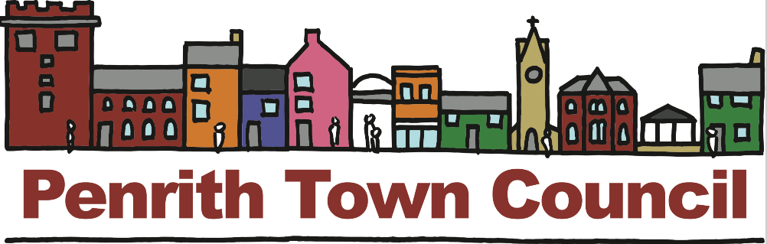

Reminder - Get involved in the Regulation 14 Consultation for Penrith’s Neighbourhood Development Plan (PNDP)
The Regulation 14 Consultation for the draft PNDP has now begun. The Town Council are pleased that some of the questionnaires sent out last week to every household and business in Penrith have already been completed and returned to their offices. The hope is that others in the town will take the time to complete the questionnaire either in hard copy or online.
During the consultation process, which ends on 1st April 2019, information will be available at the Town Council Offices between 9.00am-1.00pm Monday to Friday, and also at special drop-in sessions held at the Council’s Friargate Offices. In addition, drop-in sessions where you can view information and ask questions will continue at the Library, Sainsburys, Morrisons, and The Gathering. In-depth information and a video outlining the consultation process and next steps is available on the Neighbourhood Plan Page of the Council website.
END

