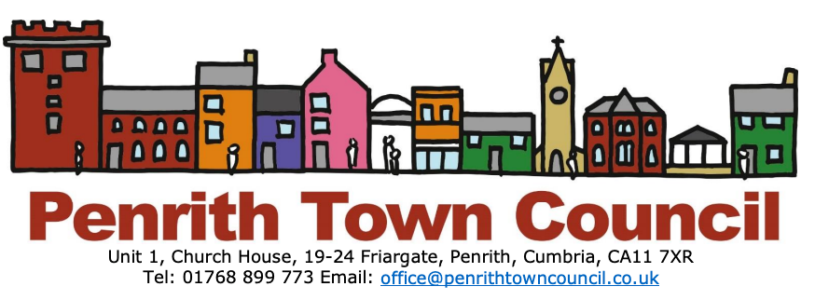
Youth Advisory Panel
“Engaging young people to facilitate, support and empower them to have a voice and influence the things that matter to them”

Penrith’s young people are the future of our town but may face significant challenges and barriers. To give them a real voice, Penrith Town Council is setting up a ‘Youth Advisory Panel’ that will enable young people who live in the Town, aged between 14-25, to advise Town Councillors about the issues that concern or affect them and other young people in the town.
Councillors will be on hand to facilitate and support them, acting as liaison between the young people and the Town Council. Cllr Hilary Snell said:
"The town council really value what young people have to say about their town. We want young people to be able to shape the panel in their own way so that they can influence decisions the Town Council make and feel as though they have a voice in the town where they live."

The Council are holding an open event for young people on 30th November, at Unit 2, 19-24 Friargate CA117XR (next to Town Council Office), so that young people can find out more and decide how the panel should develop. Please spread the word so that as many young people as possible can get involved.

