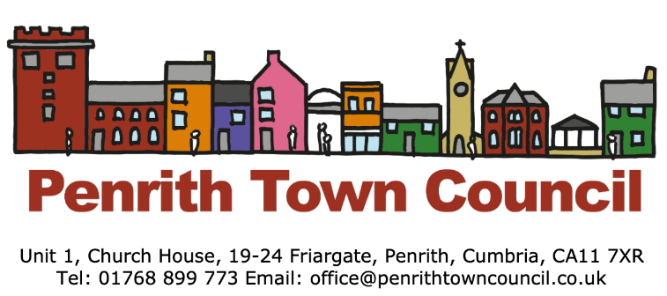
Success for Penrith in the National Britain in Bloom Competition
Every Autumn, the results of the Britain in Bloom UK finals are announced. On 25th October 2019, Penrith received two of the top awards, including a ‘Gold Award’ in the ‘large town’ category, and a new award titled ‘Growing your Community,’ one of six Discretionary awards made specifically by the judges, who described Penrith as a ‘stand out entry’ for its engagement across the community for innovative projects.
The judges were delighted with the warm welcome they received on judging day, indicating that “for quite a new entry, great things have been achieved, which in turn has changed the face of Penrith.” They remarked on how the BID had helped bring more people to visit and to enjoy shopping and the atmosphere created. The approach to recycling was commended, and the judges were also impressed by the overall quality of horticulture, including the wide variety of plants used and the variety of fruit and veg enjoyed by a wide range of people. They judges also felt Thacka Beck Nature Reserve was a “gem and a delight to visit.” The Bee keepers story was of high interest too.
Penrith’s community effort was highly commended, with the judges congratulating Joan Robinson and the team’s work on the railway station project, which they felt was a stand-out feature “all about thinking outside the box.” They also commended changes in Great Dockray, driven by Louise Armstrong, who they felt “had a skill to make things happen and bring people on board.” Other members of the community also impressed the judges, including Laura Fossil and the work in her own garden, the Salvation Army and the Gardening and Foodbank programmes; also St Catherines’ Catholic Primary School gardening driven by Dave and Maggie Neale, which they felt was “first class,” and, of course, the Polytunnel programme managed by Malcolm Carruthers.
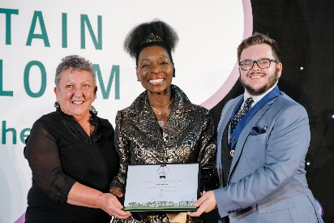
Community Gardener Louise Armstrong and Penrith Town Council Deputy Mayor Scott Jackson at the Britain in Bloom Finals, receiving Penrith’s Gold Award from Floella Benjamin, OBE DL and RHS Ambassador for Communities and Young People.
Many congratulations to all those who have worked so hard to bring these prestigious awards to the town.

